22 - 25 Sept ‘13

* Using pots as angle measurement sensors for measuring angle at joints of the arm
  + Arduino used for calibrating pots and getting feedback
* Study of model of a 4 DOF arm in MATLAB

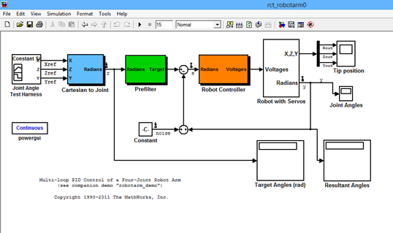

* It uses a multi loop PID control . Control is challenging because of cross-coupling between the four control loops.
* The concept of H-infinity synthesis is used for tuning all four controllers accounting for cross-coupling effects.

25-28 Sept ‘13

* Mounted the potmeter on the arm
  + problem in matching the axis of joint and pot tuner
  + could not calibrate
* Have to look for linear actuators with inbuilt encoders

28 Sept - 2 Oct’13

Linear actuator requirements:

* maximum current draw:
* proximity sensor:
* DC power supply
* Speed:
* mech
  + stroke:
  + load capacity:

Switches used in actuators that assist in control;

* Limit switch - electromechanical
* Reed switch - magnetic

Linear actuators found:

* <http://www.dcactuators.com/Detail.asp?Product_ID=306.160_6112C>
  + reed switch for feedback
* <http://www.dcactuators.com/Detail.asp?Product_ID=302.450_6112TP>
  + 10k pot for feedback

2-5 Oct ‘13

Calculating the error in position of arm tip due to inaccuracy in achieved joint angles

* Will help in determining accuracy required in actuators and sensors
* Made a simulink model for a 2 DoF system
  + takes target joint angles as input and gives the x and y coordinates accordingly
  + some error in angles is added and the resultant position is calculated
  + error in position is calculated
* Conclusion: ( for 2 DoF )
  + even a few degrees of error results in a few cm of error in positon
  + y coordinate changes more than x
* ‘getxy.mdl’ file uploaded